Session 3:

1.

QUERY:

update prescription

set notes = 'Continue medication for 2 more weeks'

where prescriptionid = 1001;

OUTPUT:

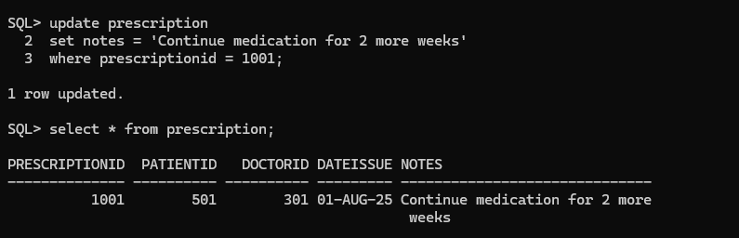

2.

OUERY:

delete from patienttreatment

where treatmentid = 805;

delete from treatment

where treatmentname = 'Skin Biopsy';

Output:

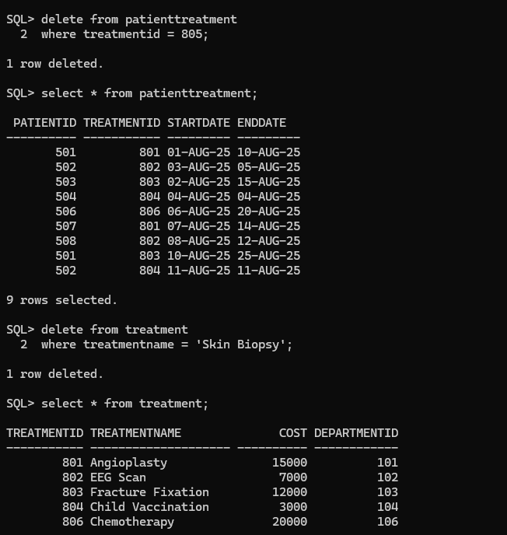

3.

ALTER TABLE Patient

ADD Allergies VARCHAR(100);

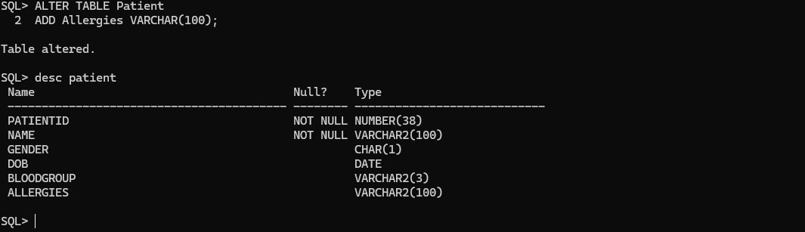

4.

ALTER TABLE Patient

MODIFY Name VARCHAR2(100) NOT NULL;

